**PROJECT – REPORT**

**The Tableau HR scorecard: Measuring Success In Talent Management**



**TEAM ID – NM2023TMID06515**

**TEAM MEMBERS:**

**TARUN K (asunm1319222104957)**

**SURENDAR J(asunm1319222104911)**

**SUBASH P(asunm1319222104955)**

**SRIDHAR E(asunm1319222104953)**

**1.INTRODUCTION:**

**1.1 OVERVIEW**

The Tableau HR scorecard is a powerful and interactive data visualization tool designed to measure and track success in talent management within organizations. Leveraging Tableau's robust data analytics and visualization capabilities, this scorecard provides a dynamic and visually engaging way to assess various aspects of HR and talent management. It enables HR professionals and decision-makers to gather, analyze and present data on key performance indicators related to recruitment, employee development, retention, and overall HR effectiveness.

By using Tableau HR scorecard, organizations can transform raw HR data into meaningful insights and actionable information. This data-driven approach facilitates a deeper understanding of talent management processes and their impact on the organization, allowing for evidence-based decision-making. Ultimately, the Tableau HR scorecard plays a pivotal role in helping companies enhance their HR strategies, optimize their talent resources, and achieve success in talent management.

**1.2 PURPOSE**

Tableau HR Scorecard is a tool that helps organizations measure and analyze various metrics related to talent management, particularly in the HR (Human Resources) domain. The purpose of a Tableau HR Scorecard for measuring success in talent management includes:

**Performance Tracking:** It allows organizations to track the performance of their HR and talent management initiatives. This involves monitoring key performance indicators (KPIs) related to recruitment, retention, training, and development.

**Visual Representation:** Tableau's data visualization capabilities make it easy to create interactive, visually engaging dashboards that can be shared with stakeholders, facilitating better understanding and communication.

**Continuous Improvement:** The scorecard allows for ongoing assessment and adjustment of talent management strategies to adapt to changing market conditions and organizational needs

**2. PROBLEM DEFINITION & DESIGN THINKING**

**2.1 EMPATHY MAP**

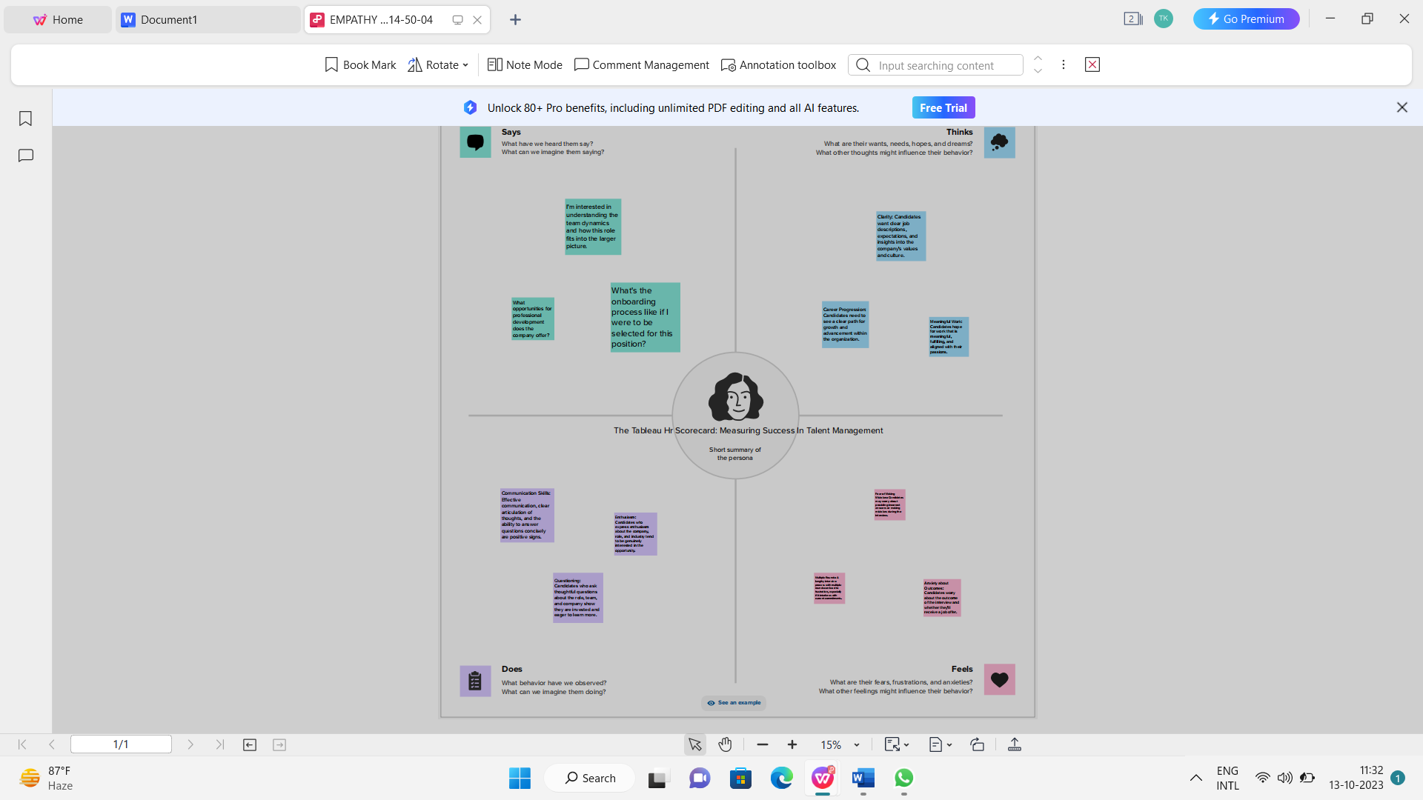

**2.2 IDEATION & BRAINSTROMING MAP**

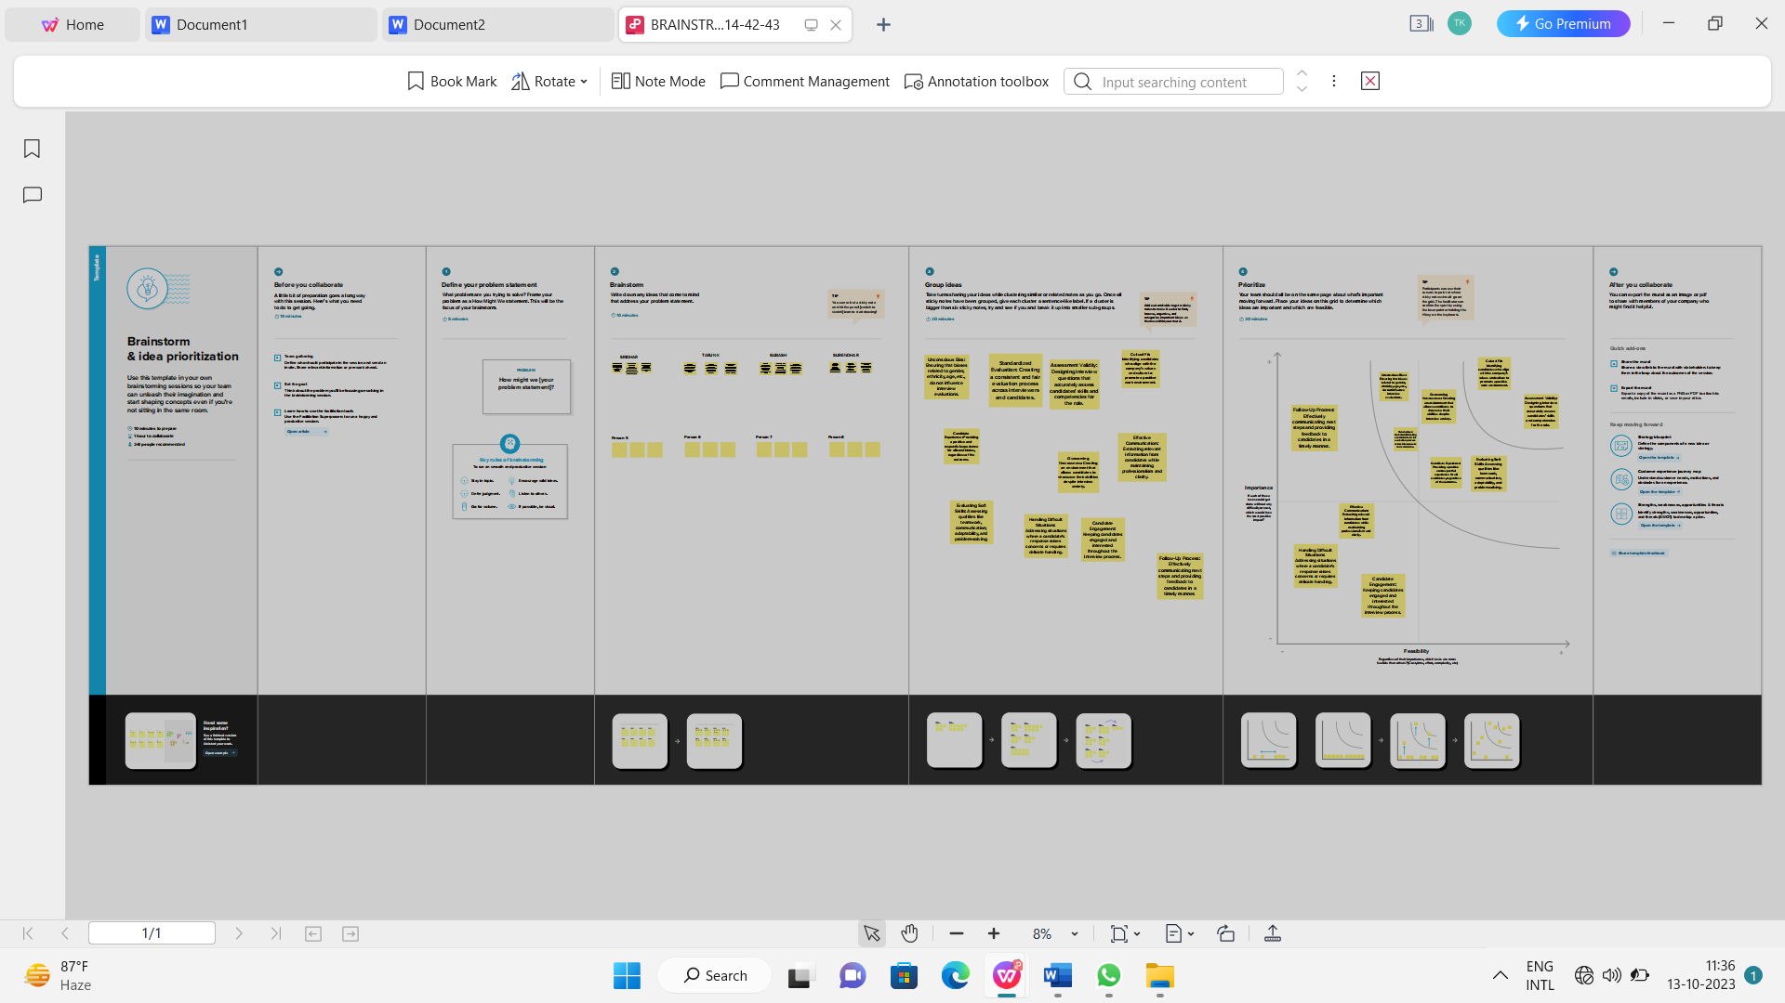

**3. RESULT**

**1.DEPARTMENT WISE ATTRITION**

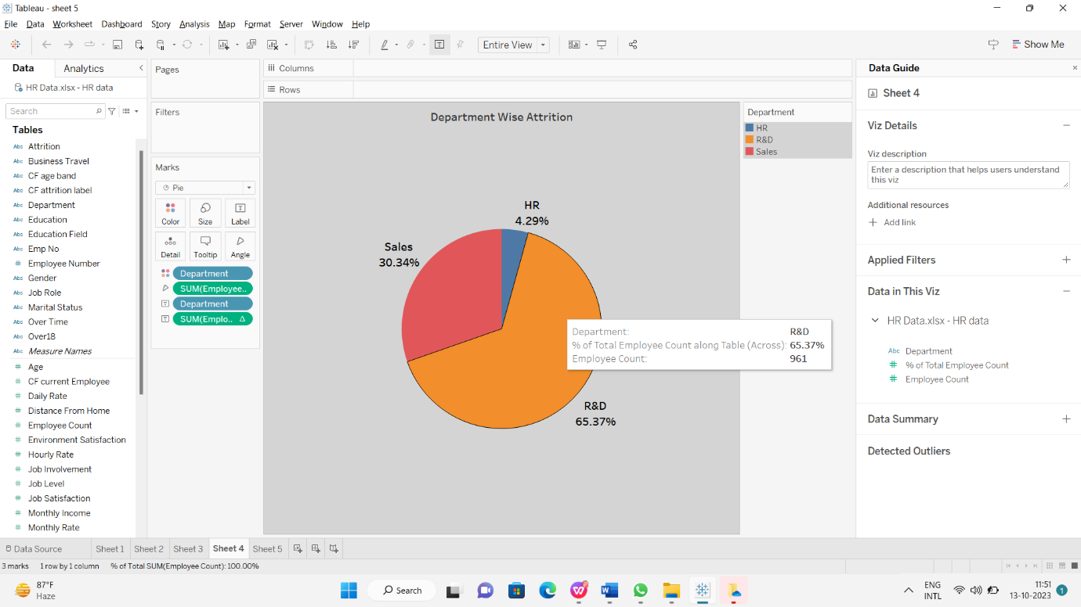

**2. NO.OF EMPLOYEES BY AGE GROUP**

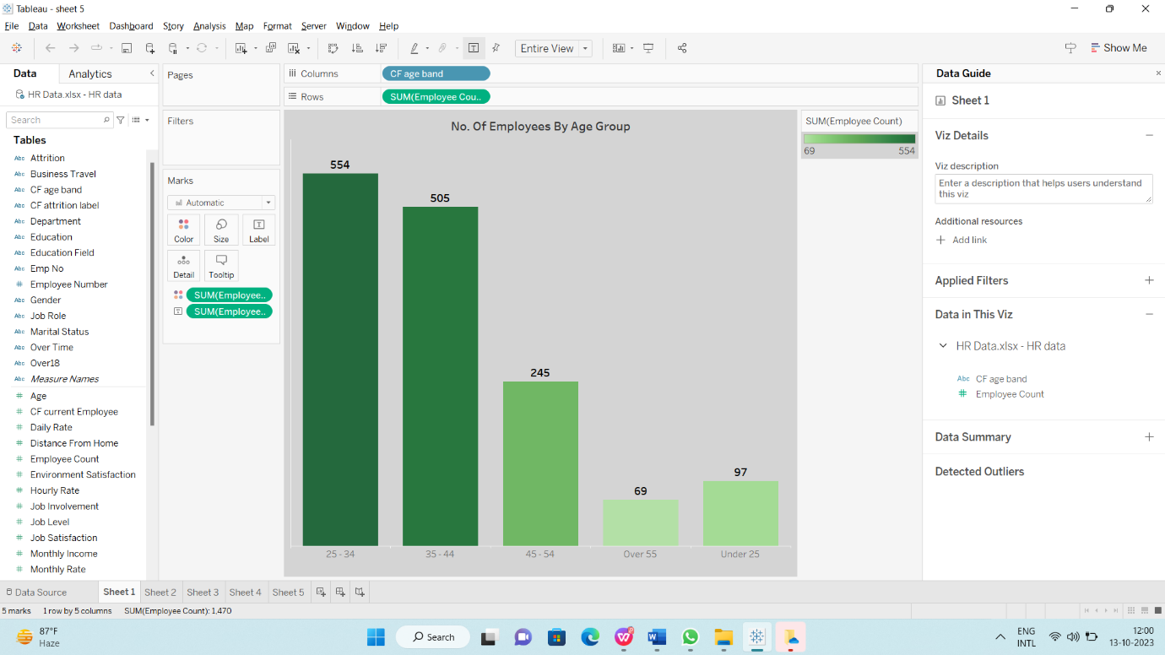

**3. JOB SATISFACTION RATING**

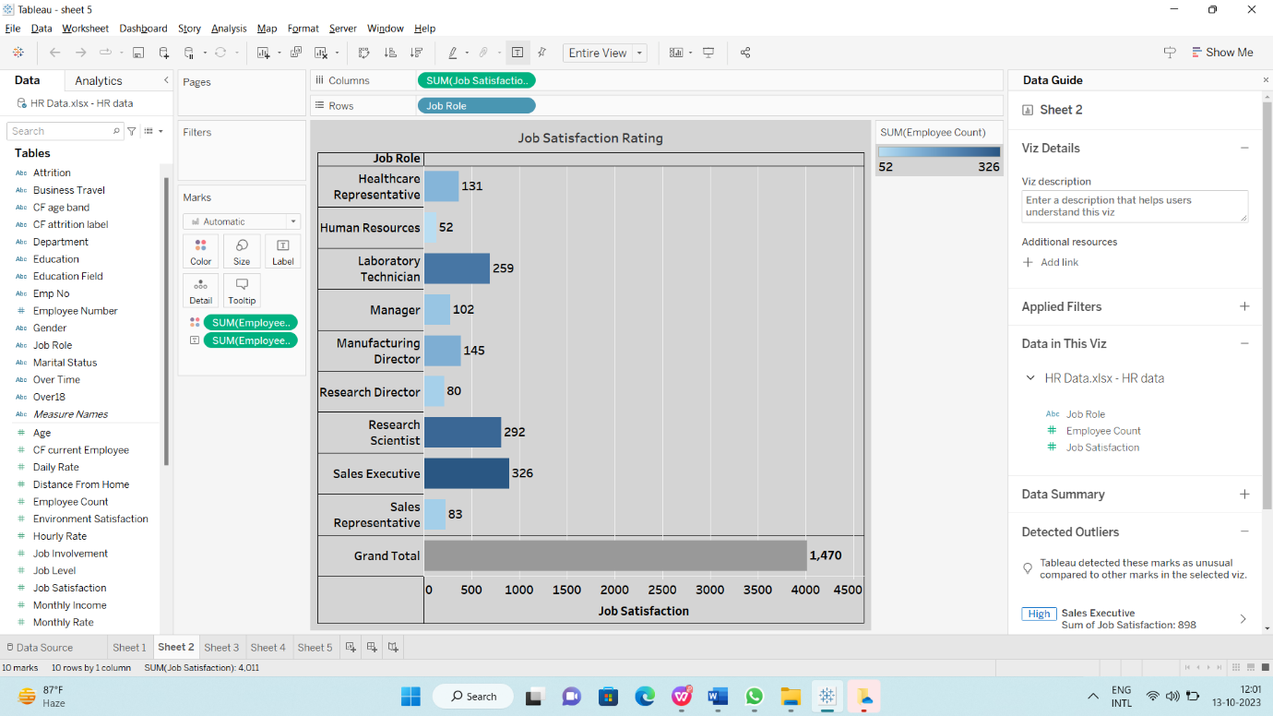

**4. EDUCATION FIELD WISE ATTRITION**

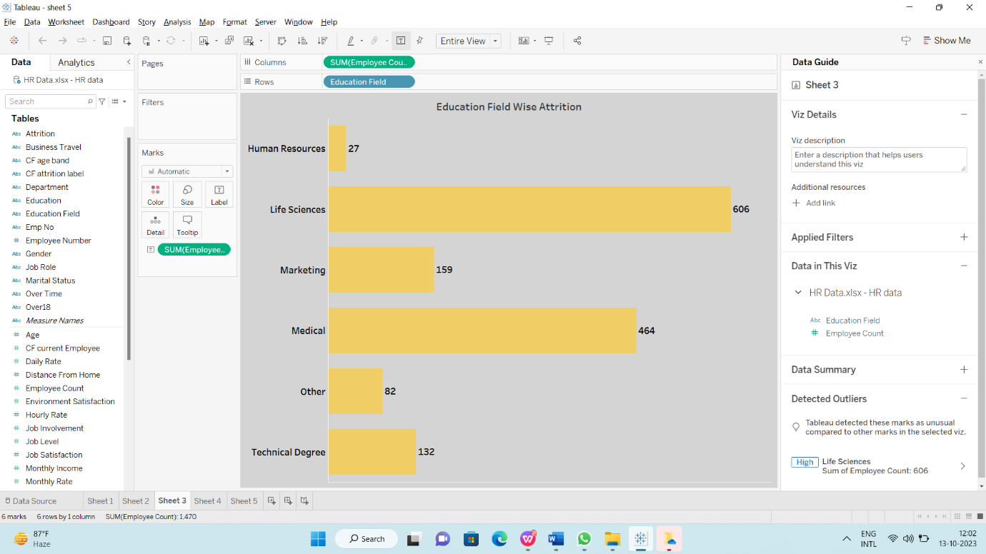

**5. MONTHLY INCOME WISE ATTRITION**

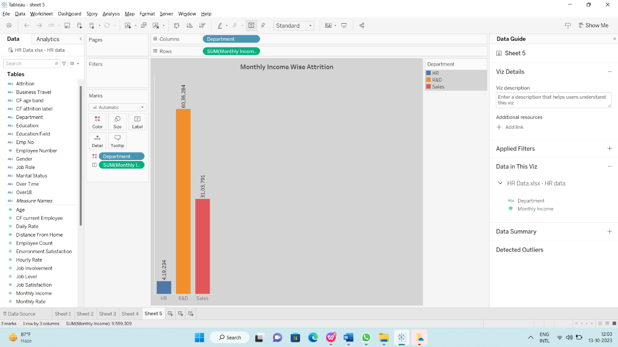

**4. ADVANTAGES & DISADVANTAGES:**

**4.1: ADVANTAGES**

**Talent Acquisition:** HR plays a key role in recruiting and hiring the right talent, which is crucial for the success of an organization**.**

**Employee Development:** HR is responsible for training and development programs that help employees improve their skills and contribute more effectively to the company.

**Compliance and Legal Support:** HR ensures that the company complies with labor laws and regulations, reducing legal risks.

**Conflict Resolution:** HR can mediate disputes and help maintain a harmonious work environment.

**4.2: DISADVANTAGES**

**Administrative Overhead:** HR functions can involve substantial administrative tasks, which can be time-consuming and costly.

**Bureaucracy:** Overly complex HR processes can lead to bureaucracy and slow decision-making.

**Resistance to Change:** HR departments may resist adopting new technologies or modern practices, hindering innovation. Cost: Maintaining an HR department can be expensive, especially for small businesses.

**Cost:** Maintaining an HR department can be expensive, especially for small businesses.

**5. APPLICATIONS:**

* By Using All These Data And Analyzing The Data’s We Have Learnt The Employees Situation, Salary, Work Timing, Mindset, Job Roles In Companies In India
* Using Tableau We Can Visualize All The Data’s For Easy Understanding

**6. CONCLUSION:**

Hereby We Understand How To Use Tableau Applications And Analyzing The Given Data. Using Tableau Application We Can Create Visualizations For Easy Understandings.

**7. FUTURE SCOPE:**

The future scope of HR scorecards for measuring success in talent management is promising. As organizations continue to recognize the critical role of human capital in their success, HR analytics and scorecards will play a vital role in optimizing talent management. Here are some aspects of their future scope:

**Data-Driven Decision Making:** HR scorecards will enable data-driven decision-making in talent management, helping organizations identify trends, strengths, and weaknesses in their workforce.

**Predictive Analytics:** HR scorecards will increasingly incorporate predictive analytics to anticipate future talent needs, attrition rates, and skill gaps.

**Employee Experience:** Measuring and improving the employee experience will become a key focus, with HR scorecards assessing factors like engagement, well-being, and career development.

**Diversity, Equity, and Inclusion:** HR scorecards will expand to include metrics related to diversity, equity, and inclusion, reflecting the growing importance of these areas in talent management.

**Automation and AI:** Automation and AI tools will assist in analyzing HR data, allowing for more efficient and accurate scorecard development.

**Skill Mapping:** HR scorecards will evolve to provide insights into the skills and competencies of the workforce, helping organizations align talent with business goals.

**Continuous Learning:** Metrics related to ongoing learning and development, such as training effectiveness and skill enhancement, will be integrated into HR scorecards.

**Remote and Hybrid Work:** Scorecards will adapt to measure the success of remote and hybrid work arrangements, including productivity, collaboration, and well-being.

**Compliance and Risk Management:** HR scorecards will continue to track compliance with labour laws and regulations, helping organizations mitigate legal risks.

**Customization:** Organizations will customize HR scorecards to align with their specific goals and industry requirements, making them more relevant and effective.